***FCTA Board of Directors***

**Angie Beans**

I have taught math for FCPS for 20 years at Catoctin High, Heather Ridge, and now Frederick High. I have been actively involved with FCTA for the last 11 years. I started as a building rep and have now been on the Board of Directors for 4 years. I serve on several committees including Negotiations, Budget, Bylaws, and Ed Reform Council. I also serve on the District Committee on Assessments. I am excited to serve as a member of the FCTA Board of Directors for another term!

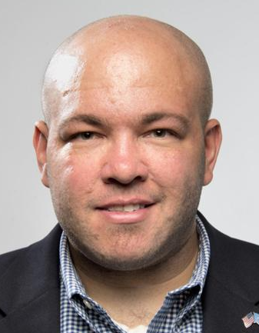

**Hayden Duke**

I am seeking a return to the Board of Directors because the challenges facing FCTA are enormous. You work hard every day for our Scholars and you deserve someone who will work equally hard for you. I will be a strong and consistent voice for our Members. As we look at the results of Election 2024 and see that two of our three candidates didn't make the cut, the urgency is clear, we will have to redouble our efforts in the community, and I pledge to you that I will work hard on your behalf. I also pledge to you that I will be available at all times to assist you in any way possible. FCTA's best days are ahead of us and I ask for your vote to be a part of that forward momentum.

**Michelle Early**

My passion and desire to help others grow, develop, and find success in life are what push me to run for this position. I truly believe that my first term with the BoD allowed me to hear the concerns of our 3300+ body and work diligently to advocate for you all. I truly believe that we are a strong, capable unit and it is my desire to continue working with educators to achieve goals that meet the needs of all. Yet I realize that two years is not long enough to fully enact change and I would like to continue working with and for you all. Thank you for the lessons, stories, and support these last two years; please, will you trust me with two more years?

**Christopher Enix**

Over twenty-three years as an educator, I have worked in four states (Florida, West Virginia, Ohio, and Maryland), five districts, and six schools, in rural, suburban, and urban public settings, a juvenile facility, and a virtual program. I have taught six grades and classes ranging from HAL to on-grade, dropout prevention, and more.

I’ve only been an employee of Frederick County Public Schools since 2021, but I’ve been a building rep since the beginning. In this time, I have been elected to represent the FCTA at the MSEA convention three years in a row. I am a current member of both the Membership and the Negotiations committees.

What makes me an ideal candidate is the unique perspective I have cultivated from the mix of outside and local experiences. I bring a fresh set of eyes while still having experience with FCPS and Association business.

**Maritza Figueroa-Mangene**

I believe in the power of solidarity and advocacy. I actively pursue opportunities to advocate for better working conditions that promote student success and educator satisfaction.

**Michael Skena**

Greetings! I am Mike Skena, social studies teacher and advocate for teachers! I have been a member of FCTA since I was hired by FCPS in 2007. I have served as a building rep for 10 years and have served numerous FCTA committees: SLB (chair), Negotiations, and Membership. I have also served on numerous workgroups, most recently with integrating the Blueprint. Recently my service to the FCTA has increased as I represented us at the NEA RA in Philadelphia this summer and the MSEA RA in Ocean City.

Reflecting on the first 18 years of my teaching career has taught me that I have many experiences that will translate into my being an effective leader of the FCTA. I look forward to representing each of you now and in the years to come!